Software Requirements Specification

Project: Advanced Reliable Real Estate Portal

Prepared by: Brij Bhushan

Semester :- 6th (Jan-April 2016)

Indian Institute of Information Technology, Guwahati

1. Introduction

1.1 Project purpose:

This is Online real estate business website through which a user can access its information and manage all the adding, updating, deleting the assets and some of its tasks.

The Admin can change the update the information regarding property selling and buying and cancellation. The system is very useful for the companies who develop apartments, hotels, residential properties and commercial properties. Companies or individual agents can also advertise their property.

**1.2** **Project Scope:**

Now a days when everything is online, how is it possible that real estate left web application behind? There are lots of real estate companies who advertise their property online so idea behind developing this application is that their property can also sell, or buy or even rent property using this. These applications are not widely popular but in future, they have large scope of growth. This website is an online real estate management through which individual agents or buyer can maintain their property. And manage all the adding, updating, deleting the ads and some of its tasks.

The system is very useful for the companies or builders that can post and edit the information of their properties and their personal info and admin can monitor records of all of them. The system is also useful which also keeps track of Account details of buyers and Investors.

**1.2** **Project Objective:**

* The system should have a login. A login box should appear when the system is invoked.
* The Admin should have all the type of authority.
* The Admin should maintain property. Admin identify property type of property.
* The property owner add, delete and update the information regarding property.
* The user should book the property for sell or rent with detail of property.

**2. Overall description:**

**2.1 Product Prospective:**

* **Admin’s interface:** Admin is a person who will handle the entire website. For that person has to give the user name and password to enter the admin page. After entering right password admin person can enter the admin home area.
* **User’s interface:** User can visit the home page of real estate in which introduction of our site is mentioned. The registered user can login from the login module. And without registration also user can search the property but for the booking the property user have to login. User can select the type of property and its budget and also find the location of property.

**3. FUNCTIONAL REQUIREMENTS:**

* Register.
* Validation.
* Keep user record.
* Add property details.
* Provide the list of properties with necessary information.
* Loan options.
* Payment options.
* Special offers.
* Book appointment.
* Accept suggestions.

**4. Specific Requirements:**

**Software requirements:**

**System Design:**

1. Use Case Diagram

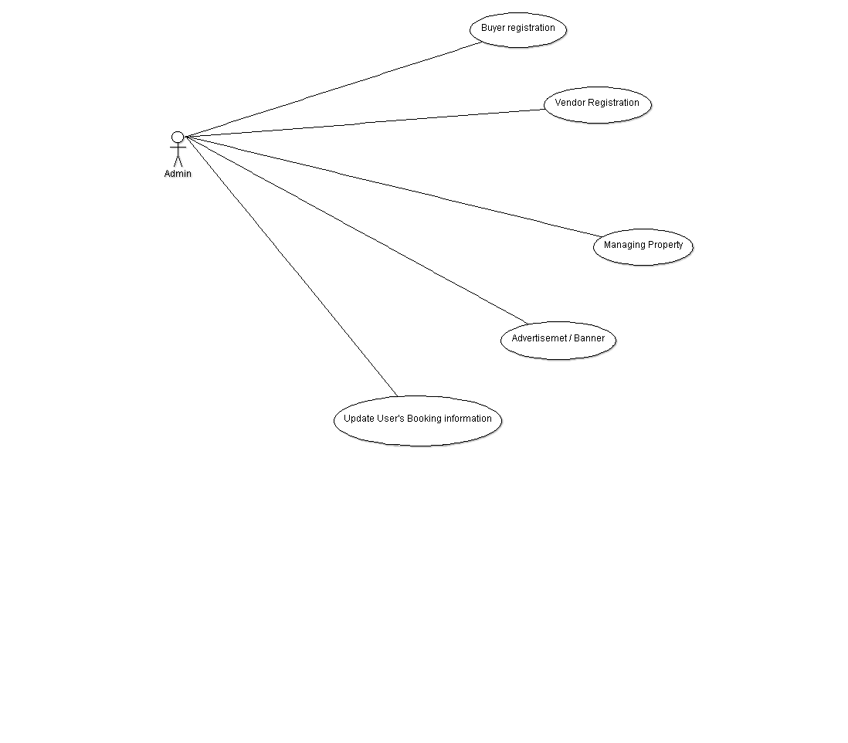

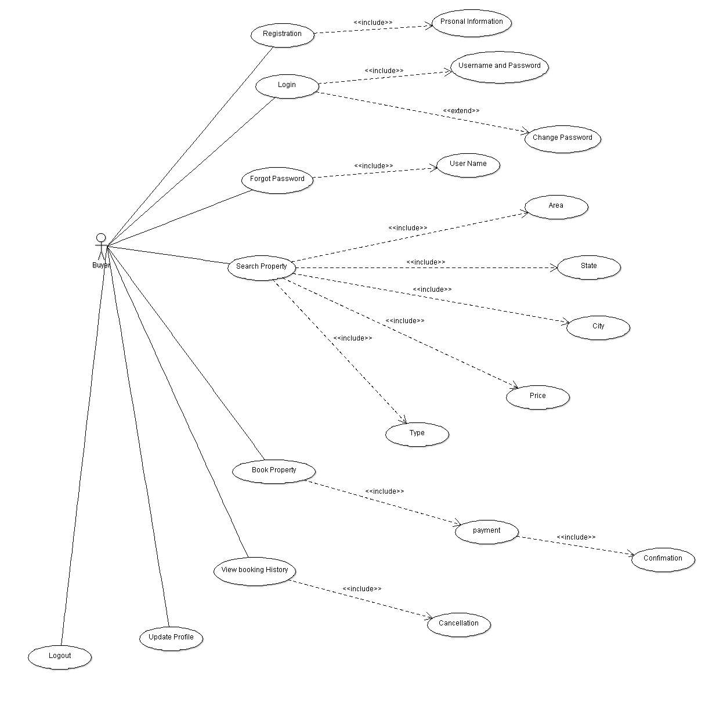

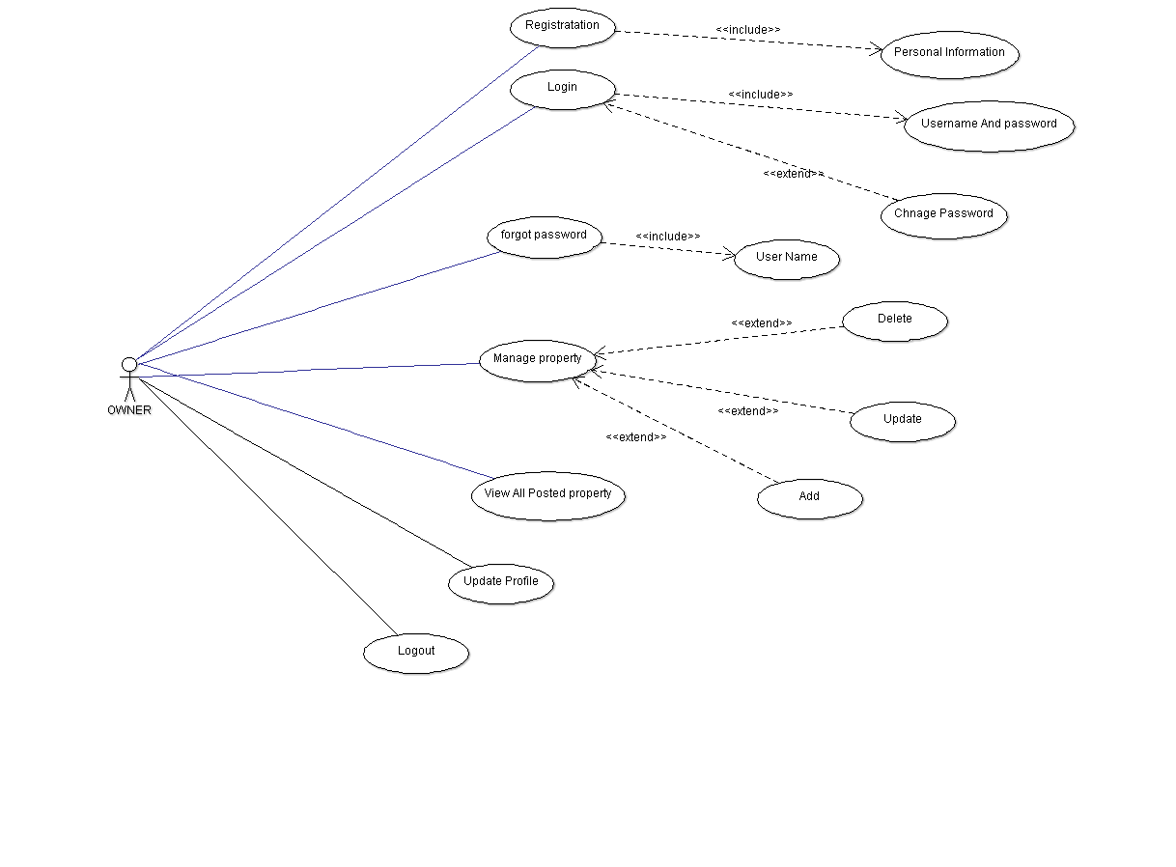

2. Class Diagram:

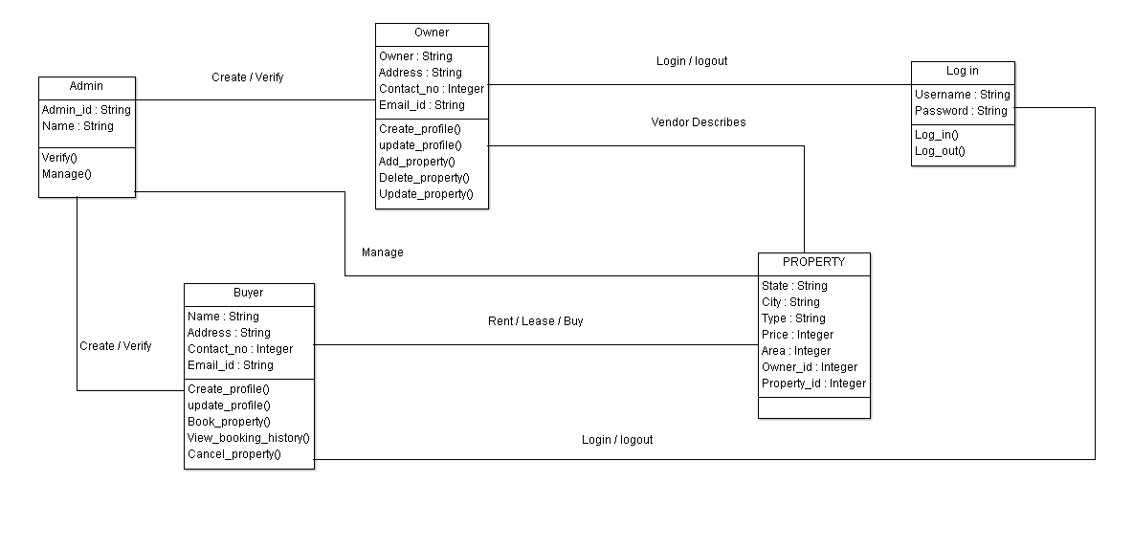

3. Sequence Diagram:

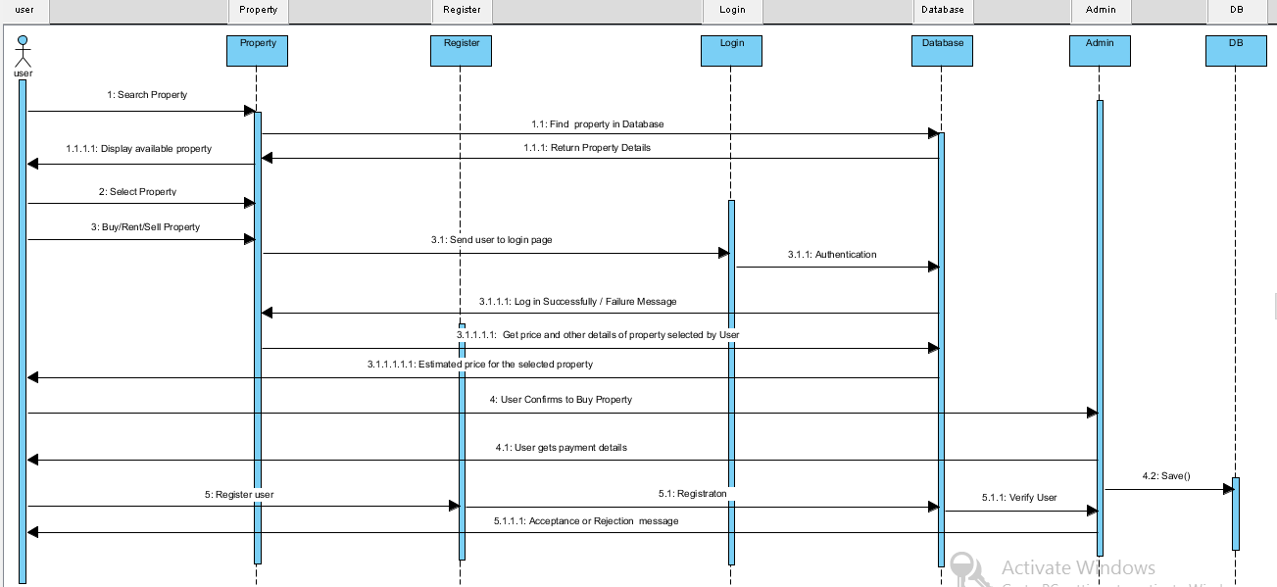

4. Data flow Diagram (0)

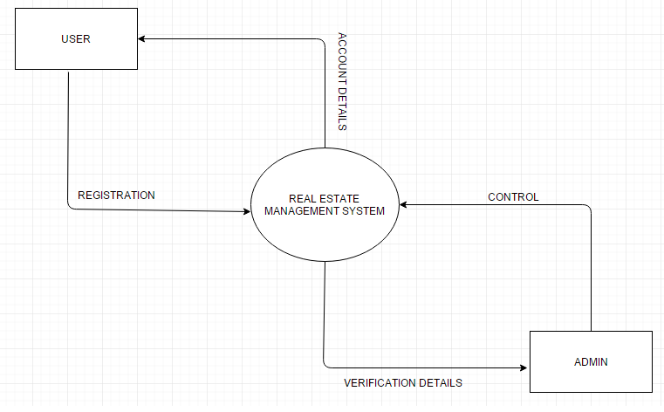

5. Data flow Diagram(1)

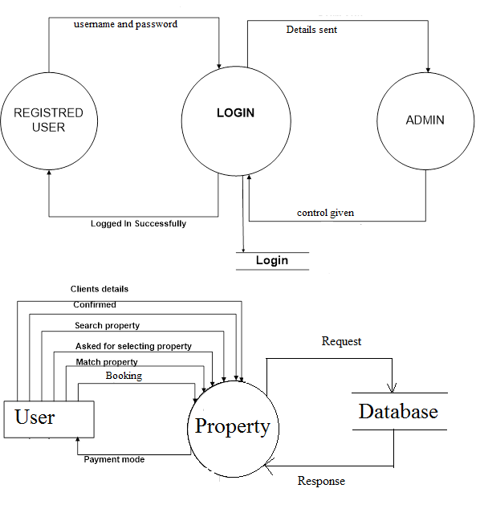

6. E-R Diagram

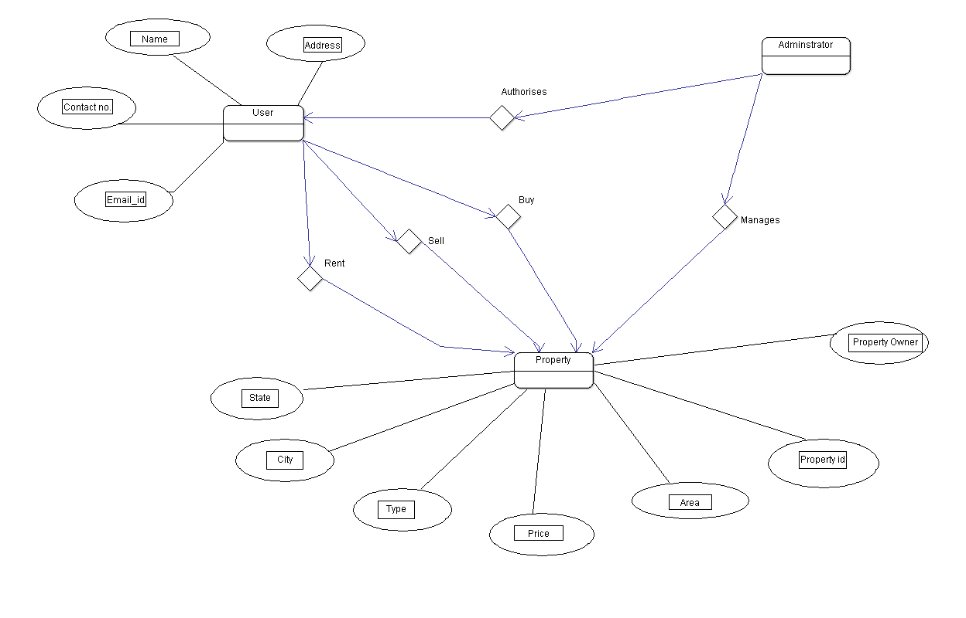

7. Activity Diagram

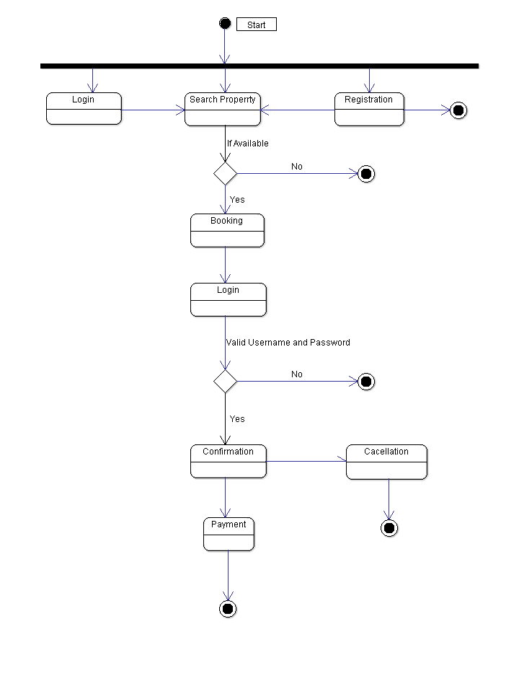

8. State Diagram

